

**Government debt and unconventional monetary policy**

# Speech given by

David Miles, External Member of the Monetary Policy Committee, Bank of England

At the 28th NABE Economic Policy Conference, Virginia 26 March 2012

I would like to thank Becky Maule and Arpad Morotz for research assistance, and others for helpful comments. The views expressed are my own and do not necessarily reflect those of the

Bank of England or other members of the Monetary Policy Committee.

**The evolution of government debt**

Most of the large, rich economies are recovering – somewhat stutteringly and anaemically – from an unusually deep and protracted recession that came in the wake of the near collapse of the financial system in 2008. During the downturn households and companies in the most developed economies cut spending; public borrowing increased massively, offsetting much of the fall in private sector borrowing. Had government fiscal deficits not increased I think the decline in demand and output in the richer countries would have been far greater. But this has inevitably led to big increases in public sector debt in many countries. When government debt increases sharply, people begin to worry about adverse spillovers to the real economy. Reinhart and Rogoff have recently argued that a public sector debt to GDP ratio of above 90% significantly depresses economic growth.1

Given the large increases in public debt in most countries, and with many major central banks expanding their balance sheets substantially and purchasing significant amounts of government debt, concerns about debt monetisation and its inflation implications have become more acute. Those concerns are understandable. But I feel they are largely misplaced – and I will explain why. But what such concerns are not is new.

Worries about the use of central banks for fiscal purposes have been around for many years. In the UK – where we have a relatively old central bank – they have been around for centuries. In 1797, the government of William Pitt the Younger (who had become prime minister at the age of 24) decided to temporarily forbid the Bank of England from paying out in gold. The decision came during the wars with France following the revolution of 1789 – wars which put a huge strain on the British government’s finances. The decision to suspend convertability so that Bank of England notes were no longer backed by gold looked to many like money financing of a deficit. A satirical cartoon, reproduced below, depicting this episode is probably the first appearance in print of the Bank of England’s nickname ‘The Old Lady of Threadneedle Street’. In the carton Pitt is shown attempting to get his hands on the central bank’s money, which is hidden beneath the dress of the somewhat distressed Old Lady of Threadneedle Street (a dress made up of money but beneath which sits a stock of gold).

At that time the stock of government debt had increased dramatically – and it was to rise further as Britain’s war with revolutionary France broadened into the Napoleonic wars.

1 Reinhart, C and Rogoff, K, ‘Growth in a Time of Debt’, *American Economic Review*, Vol. 100 (2), May 2010, pages 573-78.

**Political Ravishment, or The Old Lady of Threadneedle Street in Danger!**

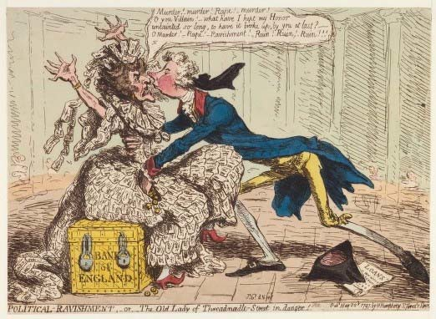

Cartoon by James Gillray, 1797.

The rise in the stock of the UK government debt in recent years has not been quite so dramatic, but is exceptional outside of a major war. In 2011, the UK government debt to GDP ratio stood at close to 65%.2 And it is forecast to rise to close to 80% of GDP over the next few years.3 That is much higher than the ‘stable and prudent’ limit of 40% of GDP outlined in the fiscal rule adopted by the previous government. But the United Kingdom has experienced debt ratios very much higher than its current level several times in the past (Chart 1). As a result of the Napoleonic Wars and the two World Wars of the twentieth century, the public debt to GDP ratio rose sharply. But it also came back down sharply in the few decades after the end of those wars. And it is wrong to say that the debt was inflated away. In the two decades following the Napoleonic War and the First World War, inflation was, on average, negative. In the twenty years after the Second World War, inflation averaged around 4% – hardly hyperinflation, though a rate of price increases high enough to have had a significant impact. But the UK government did run substantial fiscal surpluses in the years after the Second World War as the economy recovered.

On the whole, economic growth played the major role in closing huge war-time deficits. After the Napoleonic and Second World Wars the improvement in the debt to GDP ratio was associated with steady economic growth. After the First World War growth was much slower and the reduction in the debt to GDP ratio was

2 ONS data on public sector net debt, excluding the temporary effects of financial interventions. Including those effects debt was close to 150% of GDP in 2011.

3 Source: Office for Budget Responsibility.

also much slower. When growth picked up in the second half of the 1930s the debt to GDP ratio did come down fast.

**Chart 1: UK total (domestic plus external) net central government debt to GDP ratio**

Per cent

300

250

200

150

100

50

0

1692 1727 1762 1797 1832 1867 1902 1937 1972 2007

Source: Reinhart and Rogoff (2010)4, data available at [http://www.reinhartandrogoff.com/data/browse-by-topic/topics/9/.](http://www.reinhartandrogoff.com/data/browse-by-topic/topics/9/)

So it was growth in the real economy that was the key to bringing down the stock of debt – not inflation. I believe that the best way that monetary policy can help improve the fiscal positions in the current environment is also by trying to create the conditions for non-inflationary growth. In a situation with slack in the economy – such as exists in the UK and the US and across much of Europe – there is no inconsistency between the monetary policy to keep inflation low and one that helps stimulate demand and growth. In the UK monetary policy has been unusual and ultra expansionary. It is a policy which is in many ways similar to that of the Fed and the ECB. Policy has been very expansionary even though for much of the last few years the UK inflation rate has been above the target rate of 2%. Inflation has more recently fallen back towards the target. UK monetary policy is, I believe, consistent with the inflation target we have been set. Indeed, I would go further and say that it was required by the government’s remit for the Monetary Policy Committee. That remit sets out the nature of the target (2% increase over 12 months in the CPI) and then says:

“The framework takes into account that any economy at some point can suffer from external events or temporary difficulties, often beyond its control. The framework is based on the recognition that the actual inflation rate will on occasions depart from its target as a result of shocks and disturbances. Attempts to keep inflation at the inflation target in these circumstances may cause undesirable volatility in output.”5

4 Reinhart, C and Rogoff, K, ‘From Financial Crash to Debt Crisis’, *NBER Working Paper* 15795, March 2010. Data available at [http://www.reinhartandrogoff.com/data/browse-by-topic/topics/9/.](http://www.reinhartandrogoff.com/data/browse-by-topic/topics/9/)

5 This has been part of the remit of the Monetary Policy Committee since 1997. The remit is set out each year in a letter from the Chancellor of the Exchequer to the Governor of the Bank of England.

Part of that monetary policy strategy has involved very large scale asset purchases – quantitative easing (QE). My colleagues at the Bank have tried to use the more descriptive term of setting up and using an “asset purchase facility”. But that is not a snappy title. So just like in the US, in the UK it is called QE. So if QE is not about monetising government debt, what is its purpose? Let me get to that by first saying something very briefly about the framework for monetary policy in the UK.

**The monetary policy framework in the United Kingdom**

The MPC is responsible for maintaining price stability, defined by the Government’s inflation target of 2%. Here, the Fed has a dual mandate: in addition to price stability, it has the goal of achieving maximum employment. But the MPC’s inflation targeting framework does not in any way mean that the MPC ignores economic activity and employment when setting policy. The evolution of output and employment is central to the outlook for inflation. To hit the inflation target over the medium term, the MPC needs to ensure that economic activity is at a level consistent with its potential. My view – shared by my colleagues on the MPC – is that there is a margin of spare capacity in the UK economy which has been, and will continue, depressing domestically generated inflation pressures. Those domestically generated pressures are a good indication of where the underlying inflationary forces are and it is because they look very muted that monetary policy has been loosened over the recent past.

And, although some in my country have suggested otherwise, the monetary policy framework in the UK doesn’t necessarily make policy less flexible than the Fed’s dual mandate. While inflation at target is the ultimate objective, the target of 2% does not mean that we expect inflation can or should be held at this rate constantly. That would be neither possible nor desirable. Monetary policy would be changing all the time, and by large amounts, causing unnecessary uncertainty and volatility in the economy. As the remit of the MPC makes clear, this is not how policy should be set. Instead, the MPC’s aim is to set policy so that inflation can be brought back to target within a reasonable time period should shocks drive it away from the 2% level, and without creating undue instability in the economy.

The MPC’s usual monetary policy instrument is Bank Rate. But, as in many countries, policy rates effectively hit their floor during the crisis. And so the MPC has undertaken QE. This is a programme through which the MPC purchases assets, which have been overwhelmingly UK government bonds, or gilts.

The asset purchases by the Bank of England have been large (now approaching £325 billion or around

$500 billion) and have been made when the stock of government debt has been rising fast. So some people have seen the real objective of the purchases as making it easier for the Government to fund the deficit, or to push down gilt yields to reduce the rate at which the Government can borrow. But the objective of QE is the same as for a cut in the policy interest rate – Bank Rate: to prevent demand falling so much behind supply that inflation would fall below target and stay below it. And in fact QE is in some ways very similar to the Bank of England’s normal policy operation. The Bank of England, like most central banks, routinely buys

and sells government debt in the secondary market as part of its normal operations in the money markets – the only thing that distinguishes QE from those normal operations is its scale and the length of time for which the assets are likely to be held. Ultimately the Bank of England will sell much of the government debt back to the private sector once the economy recovers.

Some have questioned why the MPC has been buying government bonds, rather than private sector assets, if the objective of the purchases is to boost nominal demand. I believe that our decision to buy mostly gilts is consistent with that stated objective. The nine members of the MPC do not have a comparative advantage in making credit decisions – the comparative advantage lies with investors whose job it is to channel credit to where they judge it will be most productive. But the MPC can encourage the flow of credit to the real economy by purchasing government bonds. When the Bank of England buys gilts from the private sector, it is likely that the sellers will increase their demand for close substitutes for gilts – other long-dated risky assets, like corporate bonds and equities – driving their price up. Since the Bank of England began QE in March 2009, the spread between yields on corporate bonds and gilts have fallen by 1500 basis points (for high yield bonds) and 130 basis points (for investment-grade, non-financial corporate bonds; Chart 2). And UK equity prices have risen by over 50% (Chart 3). Part of those developments reflects factors besides QE. And the trends in corporate bond spreads and in equities look quite similar in the US and in much of Europe. But the Fed and the ECB have also undertaken asset purchases and their balance sheets, like that of the Bank of England, have increased enormously. I believe that a significant part of the movements in prices of private sector, risky assets reflect asset purchases by central banks, even though most of the assets purchased have been liabilities of governments. And I think a significant part of the fall in spreads on sterling corporate bonds is specifically linked the Bank of England’s purchases of gilts.

**Chart 2: Sterling corporate bond spreads for financials, non-financials and high yield(a)**

Basis 3500

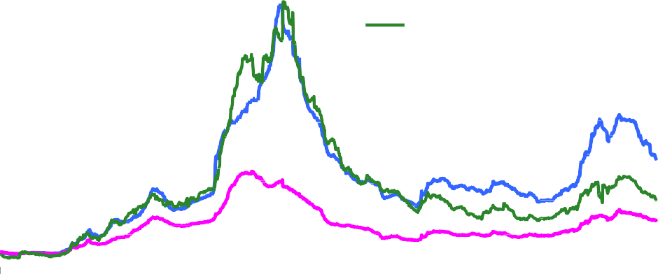

points

Basis

Financials (rhs)

Non‐financials (rhs) High yield (lhs)

3000

2500

2000

1500

1000

500

points 1200

1000

800

600

400

200

0 0

2007 2008 2009 2010 2011 2012

Sources: Bank of America/Merrill Lynch and Bloomberg.

(a) Spreads of corporate bond yields over reference gilt yields.

**Chart 3: UK equity prices(a)**

2007 2008 2009 2010 2011 2012

Source: Thomson Reuters Datastream.

(a) FTSE 100.

**QE: are the Bank of England’s actions unique?**

7000

6500

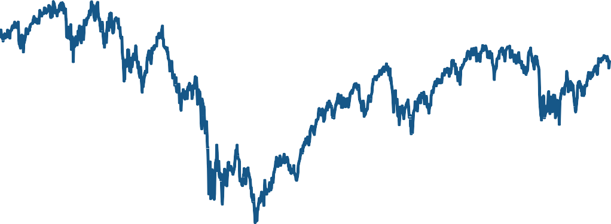

6000

5500

5000

4500

4000

3500

3000

The Bank of England’s monetary policy actions have led to an enormous expansion in its balance sheet (Chart 5). The balance sheet is now about four times as big as it was at the start of 2007, and is over 20% of annual nominal GDP (Chart 4). The Bank of England is not alone. The Fed’s balance sheet is over three times bigger than it was before the financial crisis (Chart 6), close to 20% of GDP (Chart 4). And the ECB’s balance sheet is now over two and a half times as big (Chart 7), and is over 30% of GDP (Chart 4).

**Chart 4: Central bank balance sheet to GDP ratios(a)**

nt 35

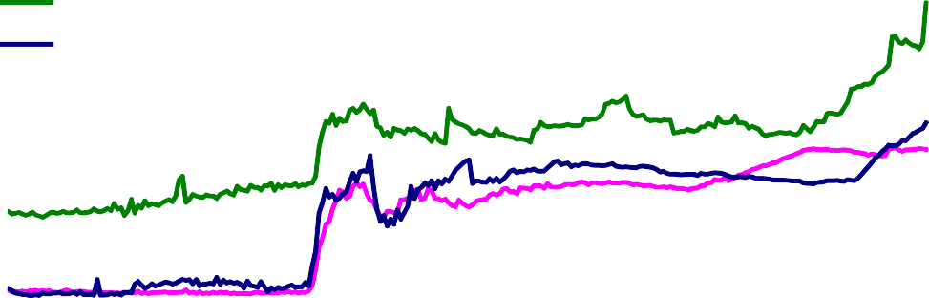

Per ce

Fed

ECB

Bank of England

30

25

20

15

10

5

0

2007 2008 2009 2010 2011 2012

Sources: National accounts data, Federal Reserve, ECB, Bank of England, Bank of England calculations.

(a) Based on quarterly annualised nominal GDP. Q1 2012 GDP figures assumed unchanged from Q4 2011.

**Chart 5: Bank of England assets**

£ 350

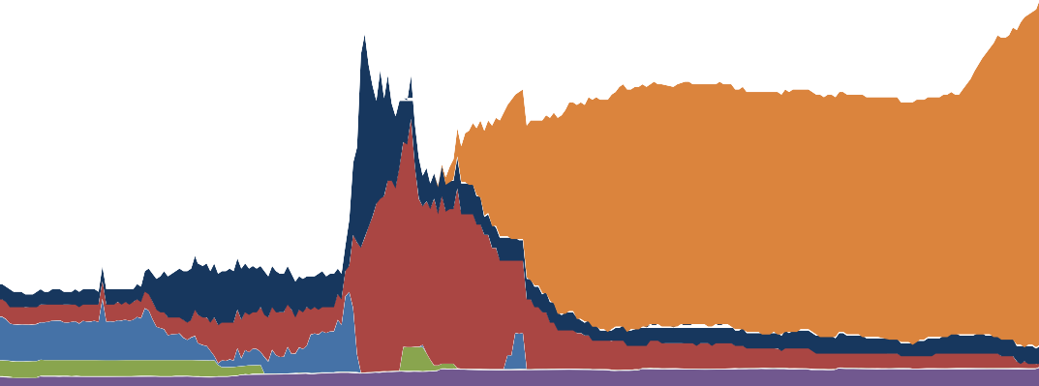

bn

Loan to APF (a)

Longer‐term sterling reverse repo Ways and means

Other assets

Short‐term open market operations Bonds and other securities

300

250

200

150

100

50

0

2007 2008 2009 2010 2011 2012

Source: Bank of England.

(a) Loan to the Asset Purchase Facility (APF) to finance the purchase of assets.

But there are differences between the actions that each central bank has undertaken. The Fed has, like the Bank of England, purchased assets which are largely government, and quasi-government, liabilities

(Chart 6). In contrast, much of the expansion of the ECB’s balance sheet has been the result of longer-term refinancing operations, or longer-term repos (LTROs, Chart 7).

**Chart 6: Federal Reserve assets**

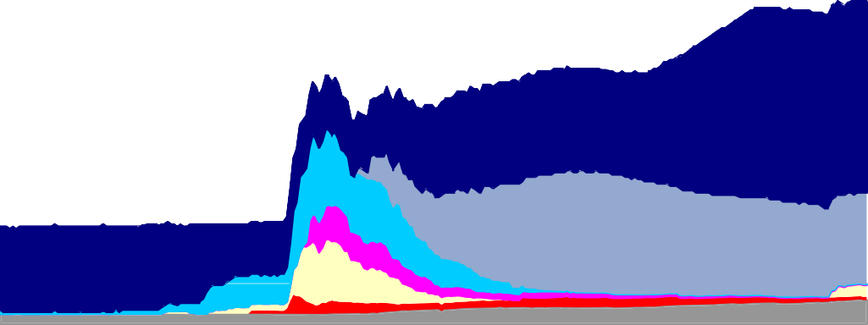

$ bn 3500

3000

2500

Treasuries and GSE debt

Loans to financial institutions

Central bank currency swaps Other

MBS

CP and ABS market support Support for Bear and AIG

2000

1500

1000

500

0

2007

2008

2009

2010

2011

2012

Source: Federal Reserve.

**Chart 7: ECB assets**

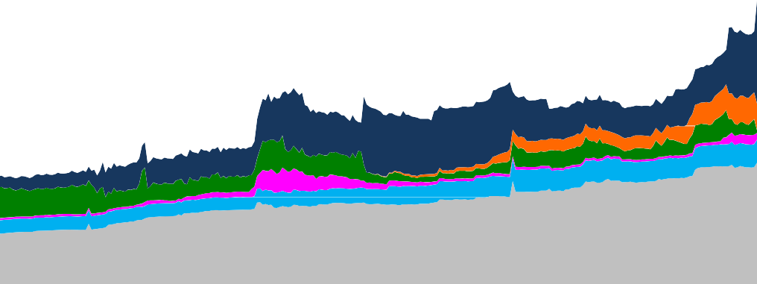

€ bn

3,500

3,000

2,500

Other, all currencies

Foreign curr. claims on RoW

Foreign currency claims on the euro area Main refinancing operation Covered/sovereign/private bonds Longer‐term refinancing

2,000

1,500

1,000

500

0

2007 2008 2009 2010 2011 2012

Source: ECB.

Some people think of long-term repos as quite different operations to asset purchases. But in general one can think of a long-term repo as an outright asset purchase, just one with a pre-announced exit plan when the asset is sold back to the counterparty for a fixed amount. In that sense it is not dissimilar to QE. But it is certainly not identical. A repo is not the same as a purchase and an agreement to sell again later since the credit risk of the assets (which is really the collateral for the loan) stays with the borrower. And in fact the ECB long-term operations do not have a fixed end date either because the borrowing by banks can be repaid before the end of the 3 year horizon. Even at the end of the 3 years loans (or repos) could be rolled over. The exit point from QE in the UK, and the point at which the Bank of England’s balance sheet will begin to shrink, is also not fixed. It will be determined, as all monetary policy decisions are, by how the outlook for inflation in the medium term evolves. When the time comes to tighten monetary policy, it is not clear that it should be done initially through asset sales. In fact it is likely that monetary policy will be tightened first using Bank Rate, with asset sales being conducted later in an orderly programme over a period of time. And once the world has returned to a more ‘normal’ time, it is not obvious that the Bank of England’s balance sheet will return to its pre-crisis size. After the events of the past few years, it may be that the UK commercial banking sector wants to hold higher reserves at the Bank of England, and so the Bank’s balance sheet could be permanently higher.

Another difference between the operations of the Bank of England and the ECB is that the counterparties to the ECB’s operations are banks, whereas the Bank of England has mainly bought assets from non-banks. That is by design: to some extent we are aiming to circumvent the banking sector to get money flowing through to the non-bank private sector.

One reason for the different approaches between the Fed and the Bank of England on the one hand and the ECB on the other reflects their distinct institutional (and constitutional) positions. The decision to purchase government assets was just much more straightforward for the Bank of England, and indeed for the Fed, than for the ECB. In the UK and US there is a single government and a single central bank – the central bank does not have to choose which governments’ debt to purchase. And, unlike for the ECB, the operations of the Bank of England (and I think also those of the Fed) are not a response to payments imbalances or large net banking flows between regions within the UK or between regions within the United States.

But despite these differences, I believe that it is misleading to characterise the actions of the Bank of England, Fed and ECB over the recent past as fundamentally different. Although our objectives, or the means by which we achieve those objectives, may differ somewhat, all three central banks have expanded their balance sheets significantly, and all have done so in response to the extraordinary situation after a financial crisis whose effects rumble on. And all have done so once the policy rate (the short-term nominal interest rate which the central bank controls) has fallen to close to its lower limit. Moreover, all three remain committed to maintaining price stability in their economies.

**Conclusion**

In the aftermath of the financial crisis, government debt around the world has risen sharply as government spending has filled some of the gap left by the retrenchment of the private sector. Those developments have raised serious questions about the solvency of some sovereigns. They have also led to heated arguments about the optimal response of central banks. In the UK, the Bank of England has purchased a very substantial amount of government bonds. Those purchases were not undertaken to finance the Government’s fiscal deficits. Rather, they were undertaken in order to offset recessionary forces that might otherwise have created a lasting depression which could have generated deflation. The aim has been to influence the cost and availability of funds to the private sector. The means to that end has been to swap government bonds for money and so trigger portfolio re-balancing that will increase the demand for assets created to finance private sector spending. The tricky task ahead for the MPC, and for the Fed and the ECB, is to know for how long to keep monetary policy at an exceptionally expansionary setting. What is the right trajectory back to a more normal setting? The challenge here is not because of any practical difficulties in unwinding asset purchases, it is the much more fundamental and timeless one of assessing the outlook for the economy and judging the appropriate monetary stance.